JetBlue BG December Mosaic Promo Storefront AB test result Update as of 2017-12-15:

The Mosaic Promo started on Dec 11th; it’s now five days into the test. The Test Storefront is generating -11% lower Revenue per Visitor.

1. The Revenue per Visitor of the Test Storefront was **-11% lower** than the Control Storefront.
2. The conversion rate of the Test Storefront was **+2% higher** than that of the Control Storefront
3. The ATS of the Test Storefront was **+4% higher** than that of the Control Storefront

You can find the report here, <https://data.points.com/#/views/JetBlue_Dec2017_Storefront_ABtest_MosaicPromo/Story>

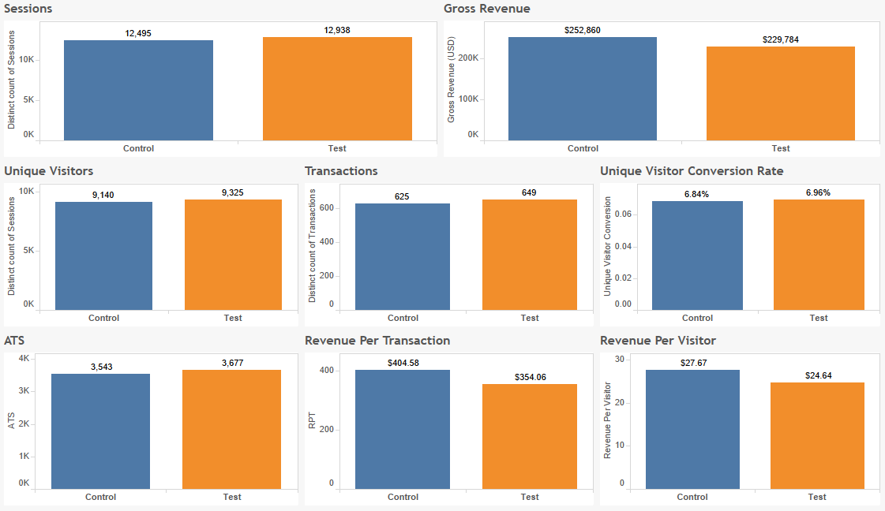

The Reason to the lower RPV even though both ATS and Conversion are higher for the Test Storefront was that a higher weight of transactions on the Control Storefront came from the Limit Lift Buy offer that is priced almost ten times as the Organic Buy offer. But none of the results is representative since it’s still very early in the promo.